

WORX™SR

Service Request version 1.0

**Add Craft, Get Opportunities, and Make Money**

Engr: Akrum Hamad

June 2018

# Contents

Contents

Introduction

Application Requirements

Technology

App Admin Backend

Themes

Sample Theme

Logo

Color schema

Landing Page (Start)

Application Business Requirements

Service Request

New SR Notification

Place Bids

Bid message Details

Messenger

Award job SR

Payment Management

Review and Rating SR

Browse Professionals or Job SR

List

Map

Account

Create Account (available in Yii2)

Login/ Logout (available in Yii2)

Reset /Change Password (available in Yii2)

View and edit Profile

Membership

CMS Blog Pages

Home (Landing Page)

About Us

Services

How to be a Resellers or Partner

Advertise with Us

Contact Us

HowTo

Policies

FAQ

User Setting

Admin Control Panel

Reseller

Design Package and Ads Plan

User Management

Professional Lists

Skills Tags

Payment Gateway Integration

Service Request Management

Mockups

Workflow

Database ER Diagram

# Introduction

A Responsive Application name **Worx™SR** is mainly organizing relationship and communication between Customers / Employers from one end with Professionals “Freelancer” on other end who are ready to serving Customers requests. Both Parties are consider users of Application and can switch from Customer to Employer “Service Provider” and vise versa. Service Provider only yield to membership subscription.

Application will be mainly used for individual, corporate companies still can be promote their services using advertisement..

**Worx™SR** aim to:

1. Organizing labor market ,
2. Utilize labor Idle time
3. Increase sales opportunities ,
4. Earn more Money
5. Enhance quality of Service
6. Maintain smart and compete Price of Services
7. Encourage Professional to sharp their Skills
8. Reward Highly Skill and best performers

**Worx™SR** will be mainly in English Languages , but can be translated to any languages as Arabic, Hindi, Urdu, Chinese, Turkish, ...etc. [1]

Currency , detected as per country and can be automatically defined using geolocation codes to get other information as Latitude and longitude and stored in User Profile.

**Worx™SR** usage will be limited to country boundary, If user resident in other country is not applicable to use where **Worx™SR** is currently available for usage. In other word Application will be activated and translated and may be hosted locally deployed on targeted countries that we got service provider and partnership with them. **Worx™SR** It is local , but not worldwide application. Hence using Google Maps will be limited to current Country and zoom in to Regions, Cities..etc. [2]

# Application Requirements

## Technology

**Yii2 is** preferred platformas there are a lot of repositories , or plugins available in Github ..

Using Advanced template where providing backend, and frontend pages and ready Login,Register, change password , About pages...etc.

In web development of Admin and user control panel pages, is also recommended to use <https://adminlte.io/> , or similar template ..

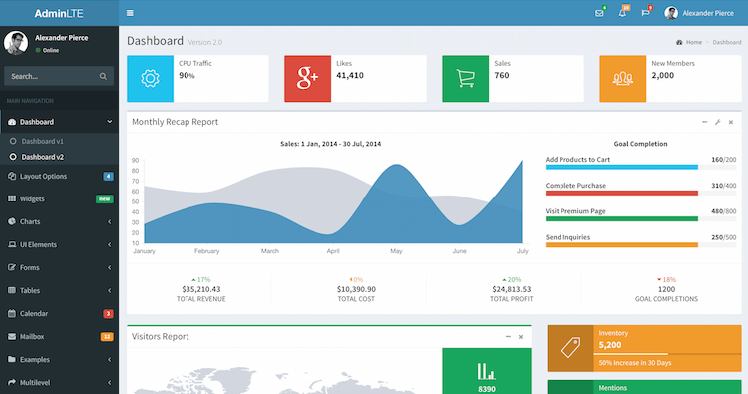

## App Admin Backend

Web Application Backend Control Panel where App Owner, or Admin can maintain App Services and Functionalities.. From Admin Backend Dashboard will show Totals of Users , Subscriptions or membership timeline and Total Amount, Revenue Generated by subscription Plans, Active Subscriptions, Expire Subscriptions to notify them encouraging them to renew.

Number of Job Service Requests Status and Amount , and Top 10 of Service Request per Professional list

Backend empowered by Modules to Handle Users, Professional List, Skills List , Subscriptions and Memberships , Membership Package Plans , Discount Plan ,Payments Gateway , Reseller , Ads management , and Languages Translation Hub.

# Themes

Using most popular Bootstrap 4.0 in rendering the Application and capability to change theme colors from Application setting.

### Sample Theme

[Mobix](https://themeforest.net/item/mobix-html-mobile-template/11093274?s_rank=3) price is $16

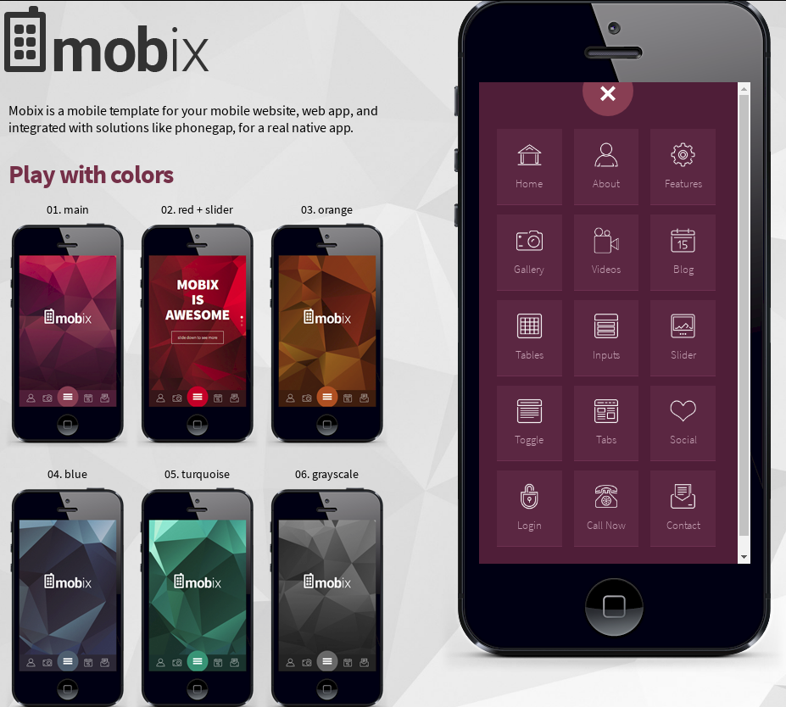

Others UI/UX

[Antiqueruby](https://codecanyon.net/item/antiqueruby-react-native/21331228) [MaterialX](https://codecanyon.net/item/materialx-android-material-design-ui-components-10/20482674) [QuickBee](https://www.behance.net/gallery/59667409/QuickBee)

## Logo

Inspired from the Bee worker who go seeking for flowers and work hard to produce Honey!. User will be like the same seeking Opportunity, craft and deliver job, then earn Money.

## Color schema

Main colors of Beehive, black text , Blue links, gray label..

## Landing Page (Start)

Background image of handyman doing works video or image,

# Application Business Requirements

## Service Request

Basically **Worx™SR** is a Project/Job/Task request in simple form user as Employer create Service Request **SR** required certain Skill or Professional who can perform this Request. So Defining Service Skill/Categories for example as Carpenter, BlackSmith, Nursing, Programmer, Teacher,...etc. so **SR** Fields might be as follow

ID

Request Date

Employer Name

Category (Plumber,Garden,Carpenter,Designer,Electrician…,etc)

Sub-Category (Design - Graphic/Decor,....,etc)

Title

Details

Duration

Budget

Required Skill

Status (Draft, Published,Awarded,Completed,Closed)

Expiry Date ( Request Date + Default 7 Days )

Assigned to (awarded to someone)

Location (lat,lng)

All Highlighted fields will filled by user [Employer]. Rest Fields will be maintained by app APIs.

By default SR status is Draft till Employer publish it. App will ask for immediate hiring professional by select from list or from map pins. Other alternative to ask Professional to place their bids.

## New SR Notification

Once Employer Publish new Job Service Request and based on Professional Category, and Skills required to accomplish Job request. App APIs will send notifications to professionals meet category and skills as per SR. Professionals who will participate will using messaging module linked to SR and place their comment, and bid their quotes

## Place Bids

Hence Employer will receive messaging threads from professionals and compared them, then hire/award the SR to the candidate he feel he can deliver the SR.

The best practice is to wait for Professional responds and select candidate based on best performer, cost, and reviews.

## Bid message Details

Professional once he Click Place Bid, it takes him to form to write his message and amount of money he ask , App will help in winning the bid by give hints of smart low, and max price he can ask or average price , and when he can start and finish the job [timeframe].

Messages Table may constructed as follow

ID

request ID [Service Request Foreign Key]

Message Date

Account Id

Employer Id

Message Text

Bid Amount

## Messenger

All bids /awards messages between parties will be through message module . It looks like these images.. In second image it shows the chat between parties for above Job “write an android/phone App…”

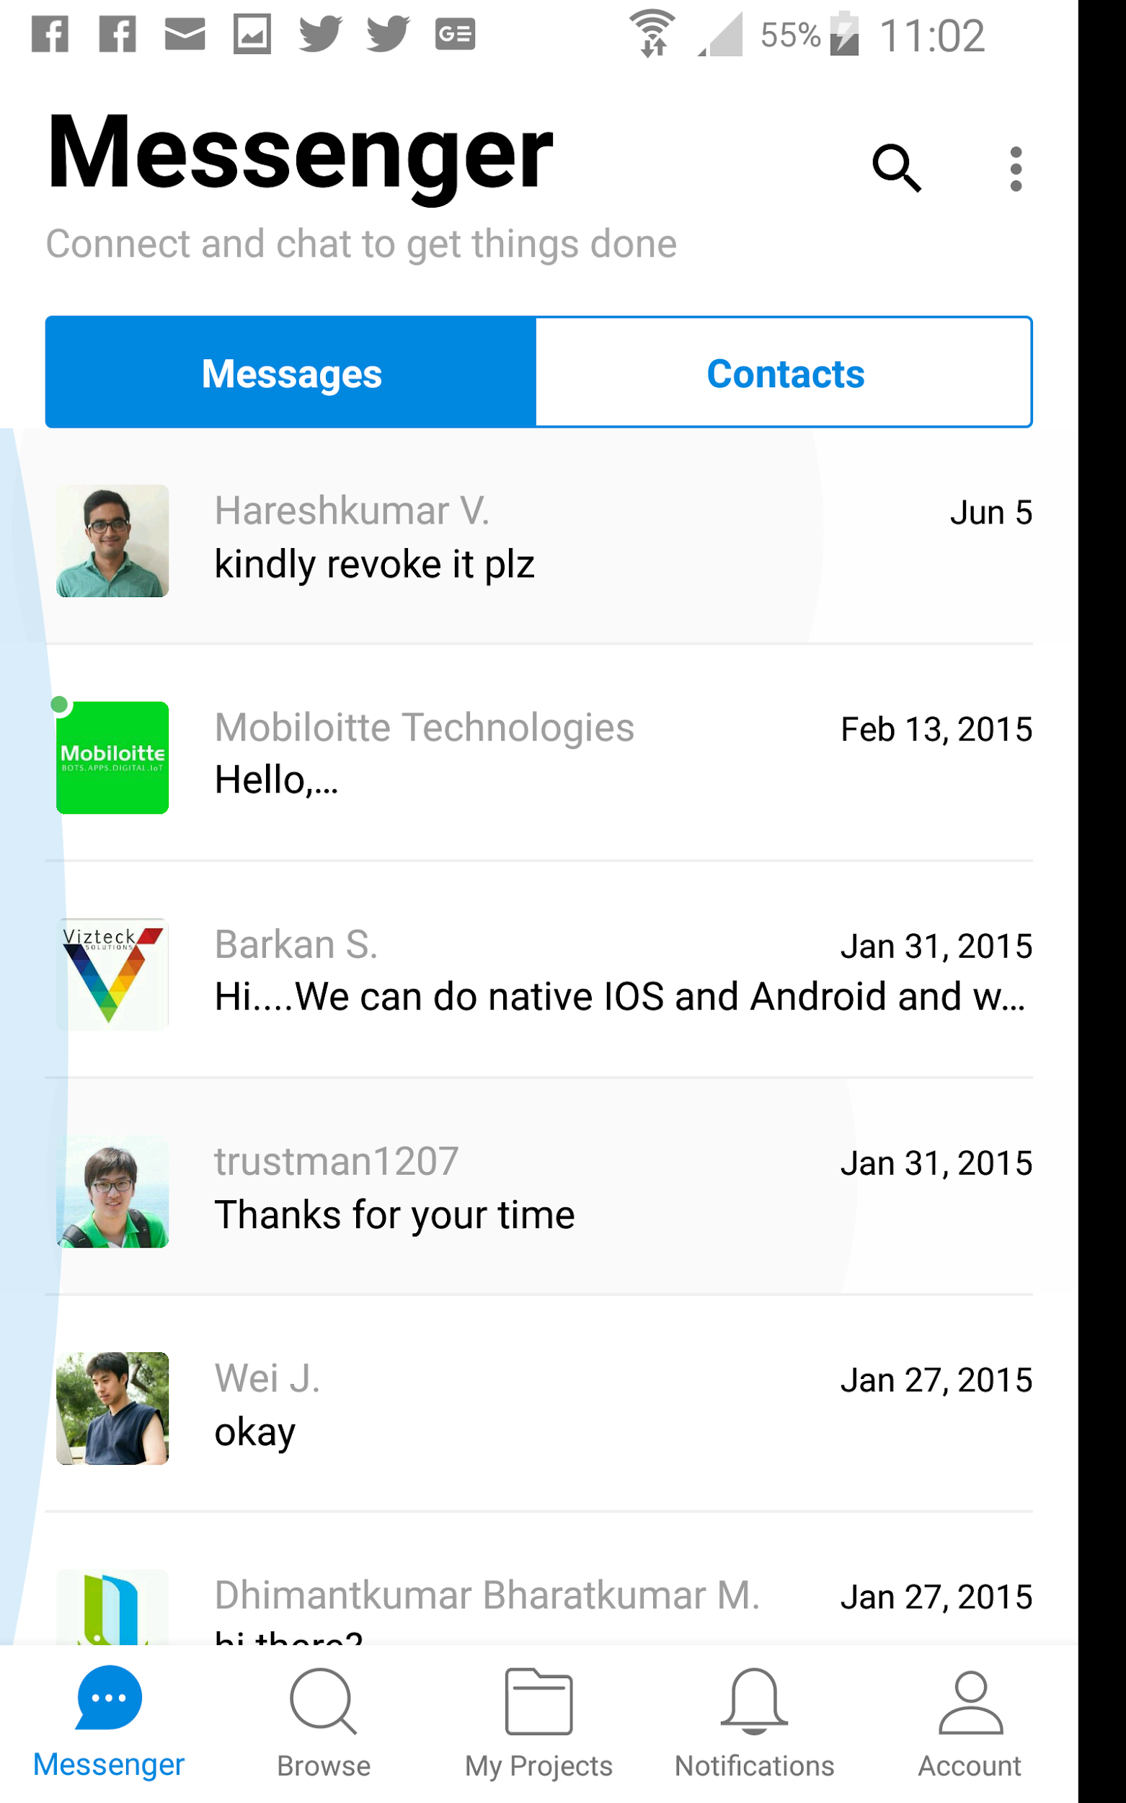 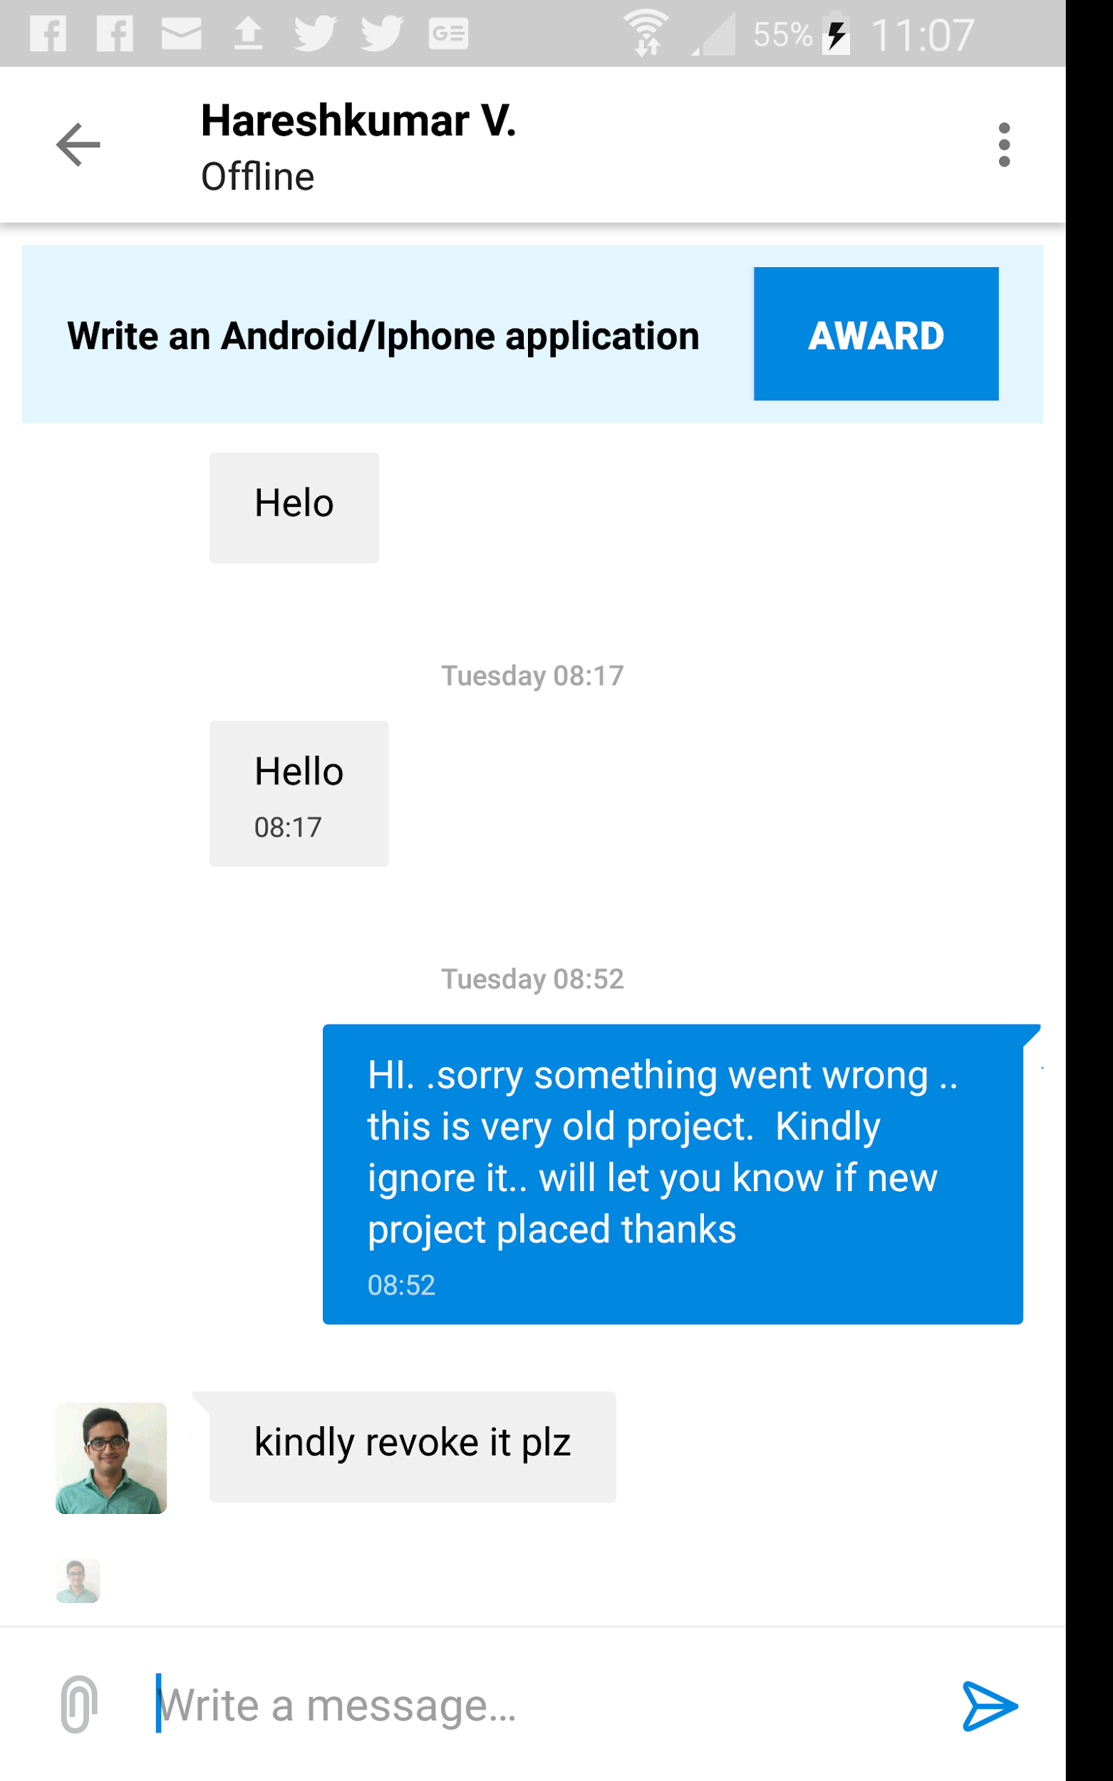

## Award job SR

Employer can award the Jobs Service Request to candidate to deliver the Job SR. Job SR status will be assigned to selected candidate and turn SR status to **Awarded .**

## Payment Management

After Service Request SR is delivered. Employer will pay Professional as agreed and SR status turn to Completed . Payment will be outside Application.[3]

## Review and Rating SR

Both Parties will notify to write their reviews and rating their experience with SR.

Employer will Rate Professional on 4 main Factors

1. Communication,
2. On Budget,
3. On time, and
4. Quality of Service.

Rating will be from 1 to 5

|  |  |  |  |  |
| --- | --- | --- | --- | --- |
| ★ | ★★ | ★★★ | ★★★★ | ★★★★★ |

Optionally Professional will write his review only about the Employer if needed

## Browse Professionals or Job SR

Searching and Browse of professionals or Service Request **SR** can be introduced in two patterns list, and maps

### List

In list you can filter and narrow search criteria using keywords like Designer.. To get most close and near professionals who works as designer.. Search box is enhanced with jquery autocomplete to fetch data from category, Skills database Tables, or view.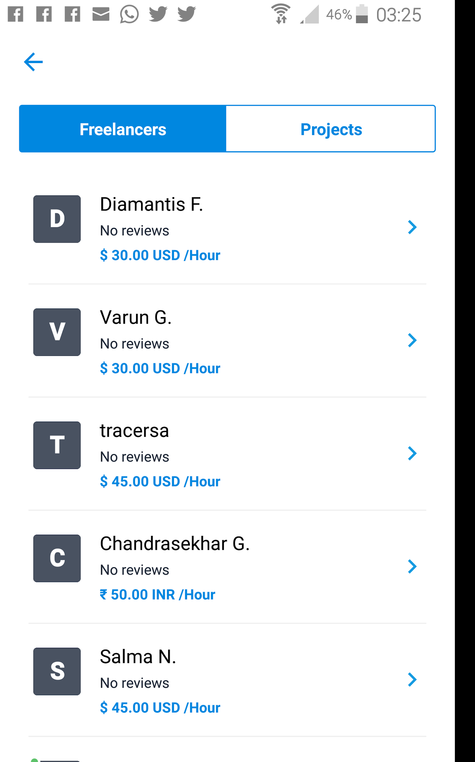

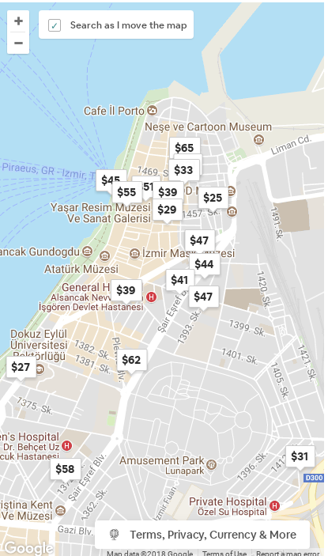

### 

### 

### 

### 

### Map

Same search criteria will display pins and location on Map to see the nearest one to your location if the closest professional is a merit than other features cost, or skill. In Map it when click the pin it pop up text box with professional Information typical as in Search

result List.

Along with Search box, a switch button enable display List view or Map view panel.

## Account

Every user will have his unique username and will complete his information and it will be appeared in search result as job Poster or Job Seeker.

User Table will be like what is available in Yii2 advanced Schema

id   
 username unique

Auth_key

password_hash  
 password_reset_token  
 Email unique

Mobile unique  
 status

role (Admin, Professional **default**, Employer, Corporate,Reseller, and Promoter)  
 created_at

updated_at

Create Account (available in Yii2)

Creating account can be using Facebook , Google account , or Email or Mobile number to register new account. Validation and checker will void duplicates as normal validation in similar application use unique account username, mobile, and email for each user.

1. By default user account role is **Professional** and can switch to **Employer** any time.
2. **Admin** who grant full access to backend to manage App.
3. **Reseller** user who can help inviting more users to subscribe with different membership Plan
4. **Promoter** who can create corporate account to manage company ads.

**Note that** : for corporate account [Promoter] , user account will extend by extra fields as website,linkedin account (will be available for all accounts, facebook account/page , instagram account, twitter account, extra photos controlled by ads plans, Fax , phone.

### Login/ Logout (available in Yii2)

To access Application will require Email or Mobile/and Password to log in , Also for quick authorization user can login using Facebook, or Google authentication ..

In case user account is Reseller or promoter , user Setting menu will show/enable Reseller and Promoter Buttons. Other wise these buttons will be Not show/Disabled.

### Reset /Change Password (available in Yii2)

App will provide facility to reset /and Change password

### View and edit Profile

View and Update Account profile date as user name, age, Sex, Address , Profession, Skill Rate per hour [default]/day/each/km/mile/ ,...etc. rate is flexible to accept any Unit of measures uom , His performance rating

### Membership

By default new Registration will enjoy 1 month order of **Silver** package (will be receive notification of any Job Service Request within city range). After expiry date he will automatically downgrade to **Blue** package (Will be Limited by city ,local Area, suburb within 5 km radius in google Map).

Silver limited by state boundary

Golden limited by Territory or region

Platinuim limited by country.

Table Structure is simply like following

ID

Package ID (Refer to the Select plan Blue, Silver, or Gold Package )

Account ID ( Account id of username Foreign Key)

Order Date

Discount_plan (select active price list per package plan)

Start date (get expiry_date in last record in membership if less than current date, use current date)

unit_price

Duration (in Days 30, 90, 180, 360)

Expiry date

Amount (duration X unit_price based on discount_plan selected)

Current_Flag ( to highlight current or latest membership

Reseller Id (account Id who is defined as Reseller or Partner)

Reseller Percentage

Note

## CMS Blog Pages

### Home (Landing Page)

### About Us

### Services

#### Resellers or Partner Program

#### Advertise with Us

### Contact Us

### HowTo

### Policies

### FAQ

## User Setting

Change profile , theme color, ...Social media accounts , notification control , manage subscription and dashboard of views , SR summary ….etc..

## Admin Control Panel

### Reseller

Admin can approve Reseller user to sell and invite more user i.e Professional to subscribe and get commission on every subscription he get for n

* New will get 5% ,
* Renew 2% ,
* Upgrade 3% .also

Resellers and promoter (company account) can manage Ads to purge corporate ads in search list based on membership plan.

### Reseller Control Panel

Has some features sell membership order (create user,select membership plan, install app or send link to install app on user , send link for payment to user using SMS to activate service or can pay using the app.. Page will show Reseller balance , list of expiry users to renew membership...etc

### Promoters Control Panel

Create ads, select plan , time frame, segment targeted , and expiry date of Ads. and payment.

Admin have access to Reseller and promoter Panels , but Reseller and Promoters can access only their tools from backend.

### Design Package and Ads Plan

For Company need to add their Ads we will have to define 3 different plans as

1. Ads meged among Search result.
2. Ads shown in top of Search result page
3. Full screen Ads

For Professional there will be different plan for example

1. Blue - Account will be shown in local area where he is available - Few Opportunities
2. Silver- Account will be Shown in the city he is work in - Moderate Opportunities
3. Gold will wide his appearance to be shown in country he works in - Large Opportunities

### User Management

To get full search and [4]CRUD functionalities on subscribed users account and Profile. And their Subscription transactions. Top 10 of Professionals based on Rating and Number of SR completed...etc.

### Professional Lists

To get full Search and CRUD functionalities of Crafts, Professional Category List.

### Skills Tags

Managing A Predefined Skill Tags linked to Professional List , so User can Select from it what Skill suit his capability. This include CRUD Functions as well

### Payment Gateway Integration

Basically App will use MyFatoorah APIs <https://www.myfatoorah.com/> this Payment will offer payment using Credit Cards, and Knet, along with other Debit Cards used in Arabian Gulf Countries. Also Can send invoices using SMS. APIs will provided to Developer when requested.

### Service Request Management

Showing charts of SR per Status, SR Number, and Amount by Professional categories

# Mockups

See attachment… called worxSR.zip file , it gives a mockup of application pages wireframes..etc.

# Workflow

See attachment included in worxSR.zip file

# Database ER Diagram

See worxsr.sql

# Use Cases

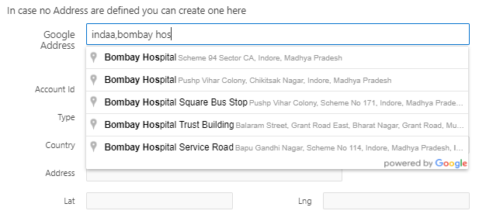

1. This introduction is part of **Worx™SR** application requirements
2. Google Maps can be downloaded to work offline
3. In progressive application versions we might introduce payment management for all parties
4. CRUD refer to Create,Read,Update, Delete Functions in SQL databases